**CHAPTER 1**

**INTRODUCTION**

* 1. **ABOUT THE PROJECT**

We are proposing this system for the flood management in districts under Kerala. our main objective is to decrease the impact of flood in both frequency and intensity by providing quick rescue services by equipped with latest technologies. For this we point the Panchayath and Taluk under the district in which the flood that was occur. And the rescue team properly locating the area or locality that causing

The victim are the common people can register for rescue and after rescuing the people they will get the alert that they were safe and secure. For this different equipment’s that proper to the rescue and disaster are provide. Also our system provide rehabilitation. when flood strikes the life line support systems, namely communication, power supply, water supply, etc. our system plays a major role and provide health care. The flood that where passed are not managed properly due to the lack of effective line of commands. Through our system we can find the people easily even they were trapped in any were and also identify the persons we want if they were separated due to the disaster different rehabilitation center.

**CHAPTER 2**

**SYSTEM REQUIREMENTS**

**2.1 HARDWARE REQUIREMENTS**

|  |
| --- |
| * Processor : Pentium IV or above * Processor speed : 1GHz or above * Ram : 512 MB or above * Hard disk : 40 GB or above * Key board : normal or multimedia |
|  |  |  |
|  |  |  |
|  |  |  |
|  |  |  |

**2.2 SOFTWARE REQUIREMENTS**

* Web Server : WAMP server
* Internet Tools : HTML, JavaScript, CSS, jQuery
* Front End : PHP CodeIgnitor
* Database : My SQL
* Web Browser : Internet Explorer, Mozilla Firefox, Chrome
  1. **TECHNOLOGIES USED**

**PHP**

PHP, which stands for “PHP Hypertext Pre-processors", is a server-side, HTML embedded scripting language used to create dynamic Web pages. Much of its syntax is borrowed from C, Java and Perl with some unique features thrown in. The goal of the language is to allow Web developers to write dynamically generated pages quickly. PHP is open free software. In its newest version PHP5 strives to give something many users wanted for the past years, a much improved object-oriented programming functionality. New PHP versions newly rebuilt object model brings PHP in line with Java, C++ offering support for features like overloading, interfaces, private member variables and methods and other OOP constructions.

* PHP is easy to learn similar to other languages of the same use.
* PHP has a simple syntax that is quite easy to parse and human friendly.
* PHP is steady to solve problems today.
* Codeignitor-MVC framework is used.

Many of the useful functions like opening an Oracle data base and fetching email from an IMAP server are predefined. In an HTML page, PHP code is enclosed within special PHP tags. When a visitor opens the page, the server processes the PHP code and then sends the output (not the PHP code itself) to the visitor's browser.

**CODEIGNITER – MVC FRAMEWORK**

CodeIgniter is based on the **Model-View-Controller (MVC) development pattern**. MVC is a software approach that separates application logic from presentation. In practice, it permits your web pages to contain minimal scripting since the presentation is separate from the PHP scripting.



Fig: CodeIgniter MVC Architecture

* The **Model** represents your data structures. Typically, your model classes will contain functions that help you retrieve, insert and update information in your database.
* The **View** is information that is being presented to a user. A View will normally be a web page, but in CodeIgniter, a view can also be a page fragment like a header or footer. It can also be an RSS page, or any other type of “page”.
* The **Controller** serves as an intermediary between the Model, the View, and any other resources needed to process the HTTP request and generate a web page.

**HYPER TEXT TRANSFER PROTOCOL (HTTP)**

HTTP is the protocol “spoken” by Web servers. Client programs that can speak HTTP, known as browsers, are used by the people on the Internet to connect to HTTP servers. These servers provide access to distributed hyper linked documents, applications and databases. HTTP is a stateless, object oriented application level protocol that has been in the existence since the early days of the WWW. NSCA HTTP is a HTTP/1.0 compliant Web Server and is credited with being one of the first HTTP servers available. It supports multiple schemes of authentication.

**HTML**

Hypertext Mark-up Language (HTML) is the text mark-up language on the World Wide Web. The mark-up commands applied to the web based content tell the browser software the structure of document and, when appropriate, how we want the content to be displayed. It has a well-defined syntax and HTML documents have a formal structure. With the introduction of scripting languages such as JavaScript, the concept of dynamic HTML (DHTML) is becoming more and more 5 popular and is used to create highly interactive web pages. When browser reads a document that has HTML markup in it, it determines how to render it on screen by considering the html elements embedded within the document.

* 1. **DATABASE**

MySQL is an open source Relational Database Management System that uses Structured Query Language. Information is stored in "Tables" which can be thought of as the equivalent of Excel spreadsheets. A single MySQL database can contain many tables at once and store

thousands of individual records. It's fast, reliable and flexible. We can copy MySQL to our PCs and Laptops.

MySQL work extremely well together. MySQL is one of the easiest data bases to administrators on all platforms and because it is so lightweight, it can run on even low powered PCs. Databases are generally useful arguably the most consistent family of software products. Unlike other databases its administration is very simple and handy.

MySQL is an open source Relational Database Management System that uses Structured Query Language. Information is stored in "Tables" which can be thought of as the equivalent of Excel spreadsheets. A single MySQL database can contain many tables at once and store thousands of individual records. It's fast, reliable and flexible. We can copy MySQL to our PCs and Laptops PHP and MySQL work extremely well together. MySQL is one of the easiest data bases to administrators on all platforms and because it is so light weight, it can run on even low powered PCs. Databases are generally useful arguably the most consistent family of software products. Unlike other databases its administration is very simple and handy.

phpMyAdmin is a web based GUI front end for the MYSQL. We can create databases with MYSQL by using the create table command. There are a number of data types and functions available with MYSQL.PHP‟s MYSQL and MYSQL improved versions are easy to use, interaction should have a connection, a database select and query or command that returns a result identifier.

The features of MySQL server are:

* A very fast thread-based memory allocation system.
* Very fast joins using an optimized one-sweep multi-join.
* In-memory hash tables, which are used as temporary tables.
* The best and the most-used database in the world for online applications.
* Available and affordable for all.
* Easy to use.
* Continuously improved while remaining fast, secure and reliable.
* Free from bugs

**CHAPTER 3**

**LITERATURE REVIEW**

The IEEE with the support of the state run Kerala IT Mission, developed a portal Keralarescue.in to collect help across the state. The Chief Minister of Kerala released it as the official online portal for the state’s rescue mission. Volunteers, majorly consisting of NGO (Non Governmental Organisation) activists and the energetic youth of Kerala, made phone calls to verify the legitimacy of inflowing requests and escalated the issue regional wise to the authorities.

About 2000 peoples were working day and night to improve and maintain the rescue portal. Engineers around the world worked from different time zones to ensure developed and maintenance round the clock. Many IT companies dedicated their development teams. As the rescue operations progressed, new features that could help the operation were added, and coordination was done using the popular cloud based collaboration platform Slack. A total of 54,933 people registered themselves as volunteers in the website who helped in the rescue work. A total of 1,363,704 people visited the website and 45,587 requests were posted through the portal.

One of the main challenges faced in the initial days of rescue was the non availability of helpline numbers. Under such conditions people started posting whatsapp messages and live videos in facebook asking for help. Popular and active facebook pages with regional influence used their platform for posting help requests. Large and small groups were formed both inside and outside India to collect messages, and to spread these messages after verifying through phone calls, assigning priority by considering the number and ages of people trapped, and to prepare proper SOS messages with geo-tags to pass on to the rescue teams through the volunteers in the district level administration. Rescue requests were updated continuously. As the flood levels started rising, the state also faced critical issues in managing the relief camps, since the focus of the hour had been on rescuing maximum people.

The telecom operators made efforts to keep the networks intact the helped the relief works immensely. Many operators announced free calls and data packs over their networks during the floods to avoid any hindrance to the rescue operations.

**CHAPTER 4**

**PROBLEM DEFINITION**

**4.1 INTRODUTION**

21st century has been defined by application of and advancement in information technology. Information technology has become an integral part of our daily life. According to Information Technology Association of America, information technology is defined as“the study, design, development, application, implementation, support or management of computer-based information system”. Information technology has served as a big change agent in different aspect of business and society. It has proven game changer in resolving economic and social issues.

**4.1 EXISTING SYSTEM**

At present there is no website for flood management. Manual process is taking place now. Also note that there is no facility for feeding information in computer or doing li. In the existing system there is no line of command and due to this the time period required for saving the life of the victim is increasing. And the rescue team could not aware about the victim are where and the rescue where go without know about the victim is rescued or in trap and it also lead to waste the time of the victim is rescued by others or other rescue. And the people in the rehabilitation center could not get sufficient food, water and medical supply and the families where separated or in different center are not to get gather together due to lack of exchange in message and we cannot gather the equipment necessary for rescuing.

**4.1.1** **LIMITATIONS OF EXISTING SYSTEM**

The system current using is manual system which is slow compared to the online system

* + - Based on paper work
    - Wastage of money
    - High Effort.
    - Lack of security of data.
    - More man power.
    - Time consuming.
    - Consumes large volume of pare work.
    - Needs manual calculations.
    - No direct role for the higher officials

**4.2 PROPOSED SYSTEM**

* Our system provides online registration facility to the victim and common people.
* Our system provide the information about the peoples in rehabilitation center.
* Our system provide line of command.
* Though our system we can utilize and reduce the time to save the peoples from danger zone
* Through our system use we take precaution
* We can identify the number of people are in different camps.
* We can identify the commodities for each camp and all people can

Sponsor to that camp.

**4.2.1 ADVANTAGES OF PROPOSED SYSTEM**

* + - Save time – Through the development of these system we can reduce the time to rescue the victims.
    - Ensure commodities are properly available in the camp.
    - Trace user’s location correctly and reduce the time for rescuing them.
    - Search the people we want by giving an option for search we can ensure the people or the victim we want are safe or not.
    - Provide correct line of comment.

**4.3. FEASIBILITY STUDY**

When a proposed system is made and approved it initiates a feasibility study. The purpose of feasibility study is to identify study is to identify various candidates systems and evaluate whether they are feasible by considering technical, economical and operational feasibility and to recommend to best candidate system

* During system analysis, examine the feasibility
* The main objective is to test the technical, economical and operational Feasibility
* Different feasibility tests are:
* Technical feasibility
* Operational feasibility
* Economic feasibility

**4.3.1. ECONOMIC FEASIBILITY**

In economic feasibility, the development cost in creating the system is evaluated against the benefits derived from the new system.

It helps the authority to use this system instead of all works performing manually now. It reduces all financial situations occurred in the case of large book keeping for the historic data and the cost for forwarding all documents by the means of other time consuming media.

**4.3.2. TECHNICAL FEASIBILITY**

The proposed system is technically feasible because of the following:

* The software and hardware requirements for the development of this project is already available.
* The available equipment’s have the capacity to hold the data required to use the new system.
* This system can be upgraded after the development.
* The proposed system provides adequate responses to the user’s inquiry.

A technical feasibility study is an excellent tool for trouble-shooting and long term planning. In some regards if serves as a flow chart of how the service evolve and move through this system.

**4.3.3. OPERATIONAL FEASIBILITY**

The proposed system is operationally feasible because of the followings:

* During the development there is sufficient support for the management from the users.
* This system will be used and worked properly if it is being developed and implemented.
* There is no resistance from the user that will undermine the possible application benefits.
* The well-planned design would ensure the optimal utilization of the computer resources.

**CHAPTER 5**

**SYSTEM DESIGN**

**5.1 INTRODUCTION**

System Design develops the architectural details required to build system or product.

The system design process encompasses the following activities:

* Partition the analysis model into subsystems.
* Identify concurrency that is dictated by the problem.
* Develop design for the user interface.
* Choose a basic strategy or implementing data management.
* Identify global resources and the control mechanisms required to access them.
* Design an appropriate control mechanism for the system, including task management.

**5.2 ADOPTION OF MODULES**

**Admin module:**

Admin has the main role of this system.

* + - Register and login
    - Manage camp
    - Manage quick response team
    - Manage members
    - Display notifications
    - View details

**Flood management team (FMT):**

The main duties of the disaster management team are involved in the system is as follows.

* + - Register and login
    - Registration of camp and quick response team
    - View details
    - Assign request to QRT

**Quick Response team (QRT):**

The main duties of the quick response team are involved in the system is as follows.

* + - Register and login
    - View request from users
    - Register rescued persons details
    - View camp details

**Camp module:**

The role of camp is:

* + - Register and login
    - Requested for commodities
    - Member registration
    - Update profile
    - View details

**User module:**

The role of user module is:

* + - Register and login
    - Request for rescue
    - Update profile

**5.3 DATA FLOW DIAGRAM**

A dataflow diagram is a graphical technique that depicts information and transforms that are applied as data move from input to output. The DFD is used to represent increasing information flow and functional details. A level-0 DFD is also called a fundamental system model represents the entire software elements as a single bible with input and output indicated by incoming and outgoing arrows respectively. Additional process and information flow parts are represented in the next level, i.e., level 1 DFD. Each of the process represented at level 1 are sub functions of overall system depicted in the context model. Any processes that are complex in level 1 level will be further represented into sub functions in the next levels.

To construct the Data Flow Diagram, we use the following components.

* External entities
* Processes
* Data Flows
* Data Stores

**Data Flows**

An arrow identifies the data flow in motion. It is pipeline through which information is flown.



**Data Stores**

It is represent the stores of data within the system. They are drawn as open ended rectangles with the unique box at the closed end and the name of the data store at the open section.

**External entities**

It defines the source of destination of the system data.

**Processes**

The process specifies the transformation that is applied to the input to produce output. All operations are performed here. The process converts data into information.

**5.4 SYSTEM DFD**

**5.4.1 CONTEXT LEVEL**



**5.4.1.1 LEVEL 1 FOR ADMIN**



**5.4.1.2 LEVEL 1 FOR FLOOD MANAGEMENT TEAM**



**5.4.1.3 LEVEL 1 FOR CAMP**



**5.4.1.4 LEVEL 1 FOR QUICK RESPONSE TEAM**



**5.4.1.5 LEVEL 1 FOR USER**



**5.4 UML DIAGRAM**

The Unified Modeling Language is a standard visual modeling language intended to be used for modeling, analysis, design, and implementation of software based systems.

**5.4.1 USE CASE DIAGRAM**

A use case is the set of scenarios that describing an interaction between a user and a system. A use diagram displays relationship among actors and use cases. The two main components of a use case diagram are use case and actors. An actor is represents a user or another system that will interact with the system you are modeling. A user is an external view of the system that represents some action the user might perform in order to complete a task.

**5.4.1.1 USE CASE DIAGRAM FOR ADMIN**



**5.4.1.2 USE CASE DIAGRAM FOR FLOOD MANAGEMENT TEAM**



**5.4.1.3 USE CASE DIAGRAM FOR CAMP**



**5.4.1.4 USE CASE DIAGRAM FOR QUICK RESPONSE TEAM**



**5.4.1.5 USE CASE DIAGRAM FOR USER**



**5.4.2 MODULAR DIAGRAM**

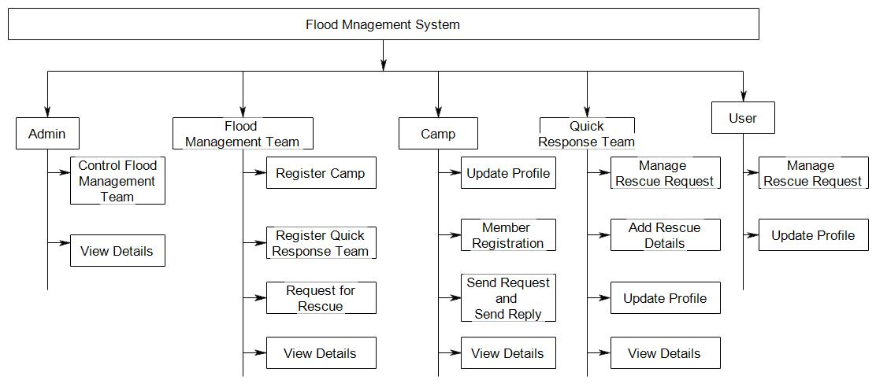

**5.4.3 SEQUENCE DIAGRAM**



**CHAPTER 6**

**IMPLEMENTATION**

**6.1 INTRODUCTION**

The creation of the designed system takes place in the implementation phase. Development phase overview, preparation of implementation, computer program development, development phase report and overview. It also performs activities like writing, testing, debugging and documenting the programs. This is to review the performance of the system and to evaluate against standard or criteria.

**6.2 TABLE DESIGN**

**6.2.1 Table :tbl_login**

Primary key :log_id

Description :Used to store log in details

|  |  |  |  |
| --- | --- | --- | --- |
| Name | Data type | Constraints | Description |
| log_id | Int(10) | Primary key | Login id |
| Username | Varchar(20) | Not null | User name |
| Password | Varchar(20) | Not null | Password |
| Usertype | Int(10) | Not null | Login type |
| Status | Int(10) | Not null | Status of the field |

**6.2.2 Table :tbl_state**

Primary key :state_id

Description :Store the details of state

|  |  |  |  |
| --- | --- | --- | --- |
| Name | Data type | Constraints | Description |
| state_id | Int(11) | Primary key | State id |
| State_name | Varchar(20) | Not null | State name |

**6.2.3 Table :tbl_dist**

Primary key :dist_id

Description :Store the details of district

|  |  |  |  |
| --- | --- | --- | --- |
| Name | Data type | Constraints | Description |
| dist_id | Int(11) | Primary key | District id |
| State_id | Int(11) | Foreign Key | State id |
| Dist_name | Varchar(20) | Not null | District name |
| locality | Varchar(30) | Not null | Location of district |

**6.2.4 Table :tbl_thaluk**

Primary key :thaluk_id

Description :Store the details of thaluk

|  |  |  |  |
| --- | --- | --- | --- |
| Name | Data type | Constraints | Description |
| thaluk_id | Int(11) | Primary key | Thaluk id |
| dist_id | Int(11) | Foreign Key | District id |
| State_id | Int(11) | Foreign Key | State id |
| Thaluk_name | Varchar(20) | Not null | Thaluk name |

**6.2.5 Table :tbl_pan**

Primary key :pan_id

Description :Store the details of panchayath

|  |  |  |  |
| --- | --- | --- | --- |
| Name | Data type | Constraints | Description |
| pan_id | Int(11) | Primary key | panchayath id |
| dist_id | Int(11) | Foreign Key | District id |
| State_id | Int(11) | Foreign Key | State id |
| Thaluk_id | Int(11) | Foreign Key | Thaluk id |
| pan_name | Varchar(20) | Not null | Thaluk name |

**6.2.6 Table : tbl_camp**

Primary key : camp_id  
 Description : camp details

|  |  |  |  |
| --- | --- | --- | --- |
| **Field name** | **Type** | **constraints** | **Description** |
| Camp_id | Int(11) | Primary key | Camp identification number |
| Camp_name | Varchar(30) | Not null | Camp name |
| Camp_coordinator | Varchar(30) | Not null | Camp coordinator name |
| Contactno | Int(11) | Not null | Contact no: of coordinator |
| District | Varchar(30) | Not null | Name of district |
| Taluk | Varchar(30) | Not null | Name of taluk |
| Panchayath | Varchar(30) | Not null | Name of panchayath |
| Locality | Varchar(30) | Not null | Location of camp |
| Email | Varchar(30) | Not null | e-mail |

**6.2.7 Table : tbl_camp_request**

Primary key : req_id  
 Description : camp request details

|  |  |  |  |
| --- | --- | --- | --- |
| **Field name** | **Type** | **constraints** | **Description** |
| Req_id | int(11) | Primary key | Identification number of request |
| Camp_id | Int(11) | Foreign Key | Camp identification number |
| Title | Varchar(30) | Not null | Camp name |
| Create date | Date | Null | Create date |

**6.2.8 Table : tbl_qrt**

Primary key : qrt_id

Description : details of Quick Response Team

|  |  |  |  |
| --- | --- | --- | --- |
| **Field name** | **Type** | **constraints** | **Description** |
| qrt_id | Int(11) | Primary key | QRT identification number |
| qrt_name | Varchar(30) | Not null | QRT name |
| cordinator | Varchar(30) | Not Null | Co-ordinator name of quick response team |
| Mob | Int(11) | Not null | Contact number of coordinator |
| e-mail | Varchar(30) | Null | e-mail |
| State | Varchar(30) | Not null | Name of state |
| District | Varchar(30) | Not null | Name of district |
| Taluk | Varchar(30) | Not null | Name of taluk |
| panchayath | varchar(30) | Not null | Name of panchayath |
| Locality | Varchar(30) | Not null | Location of camp |
| speciality | Varchar (30) | Not null | Type of rescue(airlift,water resue etc.) |

**6.2.9 Table : tbl_member**

Primary key : mem_id

Foreign key :camp_id

Description : camp member details

|  |  |  |  |
| --- | --- | --- | --- |
| **Field name** | **Type** | **constraints** | **Description** |
| mem_id | Int(11) | Primary key | identification number of camp members |
| Camp_id | Int(11) | Foreign key | Identification number of camp |
| mem_name | Varchar(30) | Not null | Name of camp members |
| address | Varchar(30) | Not null | Contact no: of user |
| e-mail | Varchar(30) | Null | Email id of user |
| State | Varchar(30) | Not null | Name of state |
| District | Varchar(30) | Not null | Name of district |
| Taluk | Varchar(30) | Not null | Name of taluk |
| panchayath | Varchar(30) | Not null | Name of panchayath |
| Lat | Varchar(50) | Not null | Latitude |
| Lon | Varchar(50) | Not null | Longitude |

**6.2.10 Table : tbl_fmt**

Primary key : fmt_id

Description : details of flood management team

|  |  |  |  |
| --- | --- | --- | --- |
| **Field name** | **Type** | **constraints** | **Description** |
| fmt_id | Int(11) | Primary key | Identification no: of fmt |
| fmt_name | Varchar(30) | Not null | Name of fmt |
| cordinator | Varchar(30) | Not Null | Co-ordinator name of flood management team |
| address | Varchar(30) | Not null | Address of the fmt |
| Email | Varchar(30) | Null | Email id of fmt |
| Mob | Int(11) | Not null | Contact no.co-ordinator |

**6.2.11 Table : tbl_camp_requestdetails**

Primary key : req_id

Foreign key :camp_id

Description : details of camp request for commodities

|  |  |  |  |
| --- | --- | --- | --- |
| Field name | type | Constraints | Description |
| req_id | int(11) | Primary key | Identification number of request |
| Camp_id | int(11) | Foreign key | Identification number of camp |
| Item | Varchar(50) | Not null | Item name |
| Quatity | Int(11) | Not null | Quantity of item |
| Create_date | date | Null | Create date |

**6.2.12 Table :tbl_rescue**

Primary key : rescue_id

Description : rescued peoples details

|  |  |  |  |
| --- | --- | --- | --- |
| Field name | Type | Constraints | Description |
| rescue_id | Int(11) | Primary key | Identification number of rescued people |
| Name | Varchar(30) | Not null | Name of rescued people name |
| address | Varchar(30) | Not null | Address of people |
| e-mail | Varchar(30) | Null | Email id of people |
| State | Varchar(30) | Not null | Name of state |
| District | Varchar(30) | Not null | Name of district |
| Taluk | Varchar(30) | Not null | Name of taluk |
| panchayath | Varchar(30) | Not null | Name of panchayath |
| Lat | Varchar(50) | Not null | Latitude |
| Lon | Varchar(50) | Not null | Longitude |
| Mob | Int(10) | Not null | Contact number |

**6.2.13 Table : tbl_userreg**

Primary key : user_id  
 Description :details of user

|  |  |  |  |
| --- | --- | --- | --- |
| Field name | Data type | Constraints | Description |
| user_id | Int(10) | Primay key | Identification number of user |
| Name | Varchar(30) | Not null | User name |
| Phoneno | Int(10) | Not null | Contact number |
| Email | Varchar(30) | Null | Email id of user |
| address | Varchar(30) | Not null | Address |
| location | Varchar(30) | Not null | Location |

**6.2.14 Table : tbl_rescue_req**

Primary key : req_id  
 Description : Details of request for rescue

|  |  |  |  |
| --- | --- | --- | --- |
| Field name | Data type | Constraints | Description |
| req_id | Int(10) | Primary key | Identification number of request |
| Name | Varchar(30) | Not null | Name of the people |
| Mobno | Int(10) | Not null | Contact number |
| Location | Varchar(30) | Not null | Location of user |
| Situation | Varchar(30) | Not null | Situation of the user |
| Qrt | Varchar(30) | Not null | Quick response team |
| Lat | Varcahr(30) | Not null | Latitude |
| Lon | Varchar(30) | Not null | Longitude |
| create_date | date | Not null | Created date |
| modify_date | date | Not null | Modified date |

**CHAPTER 7**

**TESTING**

**7.1 INTRODUCTION**

System testing is the major quality control measure during software development. Testing is a set activity that can be planned and conducted schematically. Testing begins at the module level and work towards the integration of entire computer based system. Testing is a process of executing a program with the intention of finding an error. A good test case is one that has a higher probability of finding an undiscovered error. A successful test case is one that uncovers an undiscovered error. Testing phase in the **“Flood Management System”** is supposed to verify that the system does exactly what it is designed to do. The system is to be tested with the data at the extremes of the input range. This system is also to be tested for various values outside the input range. In the system that provides different validity test strategies to validate the textboxes, entries in the system. Also it can checks the system efficiency in terms of their input and output data's

**7.2 TEST PROCEDURE**

Software testing accounts for the largest percentage of technical effort in the software process. The objective of the software testing is to uncover errors. To fulfil this objective, a series of test steps unit, integration, validation and system tests are planned and executed. In this system, they can adopt various types of test strategies. These are checks the validity, accuracy of the data, etc. in the system.

**7.2.1 System Testing**

System testing validates the “**Flood Management System”** once it has been incorporated into a large system. System testing is actually a series of different tests whose primary purpose is fully exercise the computer based system. All work to verify that **Flood Management System** elements have been properly integrated and perform allocated function. They can checks the functioning of processes with respect to their input data. Also **Flood Management System** that test the system validity in a user friendly manner. Recovery testing is a system test that forces the software to fail a variety of ways and verifies that recovery testing is properly performed. Security testing attempts to verify that protection mechanisms built into a system will, in fact, protect it from improper penetration. Stress testing executes a system in a manner that demands resources in abnormal quantity, frequency or volume. Performance testing is designed to test the run time performance of software within the context of an integrated system.

**7.3 TEST CASE AND OUTPUT**

The test case is a document that describes an input, action or event and an expected response, to determine if a feature of an application is working correctly. A test case should contain particulars such as test case identifiers, test case name, objectives, test conditions, input data requirements steps and expected results. Test result emphasize how the actual results differed from the expected results. This suggests the need for re-testing and to discover the source of differences. the test phase of systems development process involves the defining of the criteria by which the system will be tested and measuring the criteria against the acceptable failure rate. Individual modules are tested during the development itself. The tests are repeated until all known errors are eliminated and the program matched the design specification.

**7.3.1 Testcases**

|  |  |  |
| --- | --- | --- |
| Project Title | : | Flood Management System |
| Software Tool | : | Php(codelgniter) |
| Test Objectives | : | Username & Password |
|  |  |  |

|  |  |  |  |  |
| --- | --- | --- | --- | --- |
| **Step No** | **Steps** | **Data** | **Expected Results** | **Actual data** |
| 1 | Enter username & click login button | username=”admin” | Should display a warning message  “fill out password field” | Login  failed |
| 2 | Enter password &  Click login button | Password=”admin” | Should display a warning message  “fill out username field” | Login  failed |
| 3 | Enter username, password &  Click login button | username=”admin”, password=”admin” | Should display “Login successful” | Login into the system |

Table 7.3.1 Test case and report

**CHAPTER 8**

**CONCLUSION AND FUTURE ENHANCEMENT**

**8.1 CONCLUSION**

By doing this project we were able to bring a new system for disaster management with the advent of technology and internet in our day to day life, we have able to offer advanced disaster managing system for decreasing the impact of disaster in both frequency and intensity.

* Save time

Through the development of these system we can reduce the time to rescue the victims.

* Provide correct line of comment.
* Search the people we want

By giving an option for search we can ensure the people or the victim we want are safe or not.

* Ensure commodities are properly available in the camp.
* Trace user’s location correctly and reduce the time for rescuing them.

The other advantages that the system offers are:

* Efficient data storage, accuracy, real-time response and user friendliness, intelligent management.

**8.2 FUTURE ENHANCEMENT**

In future we can give more advance software for Flood Management System including more facilities. Create the master and slave database structure to reduce the overload of the database queries. The system can be further enhanced and the several other functionalities can be added. The future enhancement may include the following modules.

* Mobile app

A mobile app can be included in the system with all functionalities of the website.

* Provide compensation

We like to include a module for providing compensation for the victims based on their percentage of disaster. The above mentioned points are the enhancements which can be done to increase the applicability and usage of this project.

**APPENDICES**

**APPENDIX A**

1. **HOME PAGE**

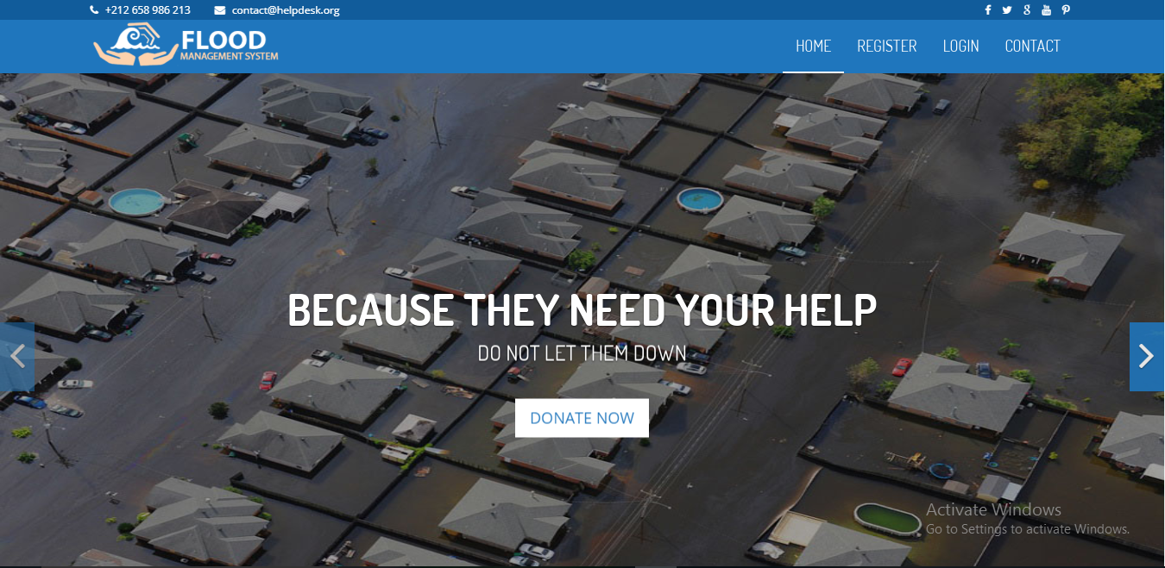

**2.ADMIN LOGIN**

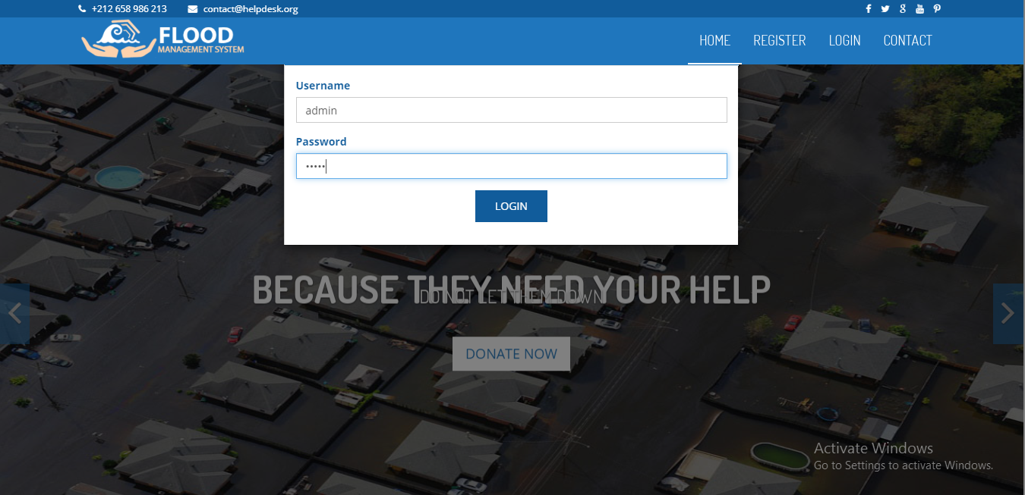

**3.USER REGISTRATION**

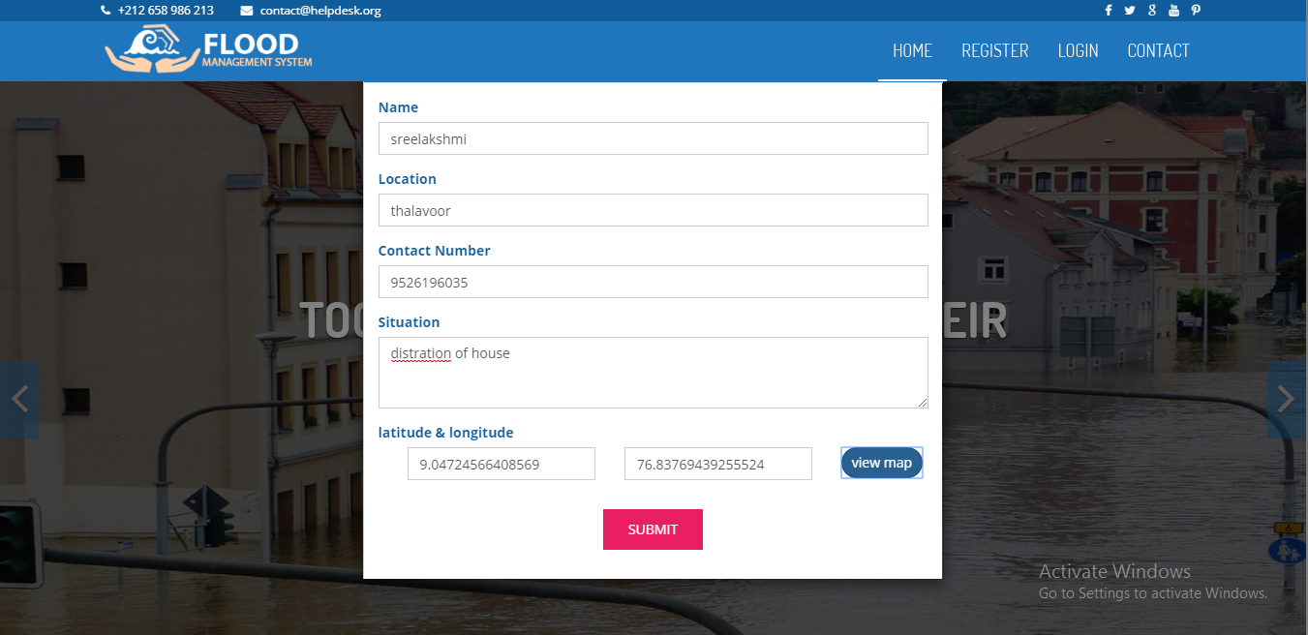

**4. NEED HELP**

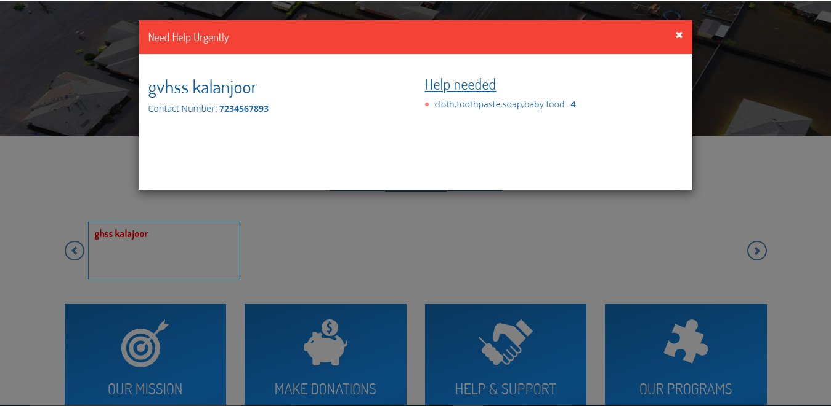

**5. VIEW RESCUE DETAILS**

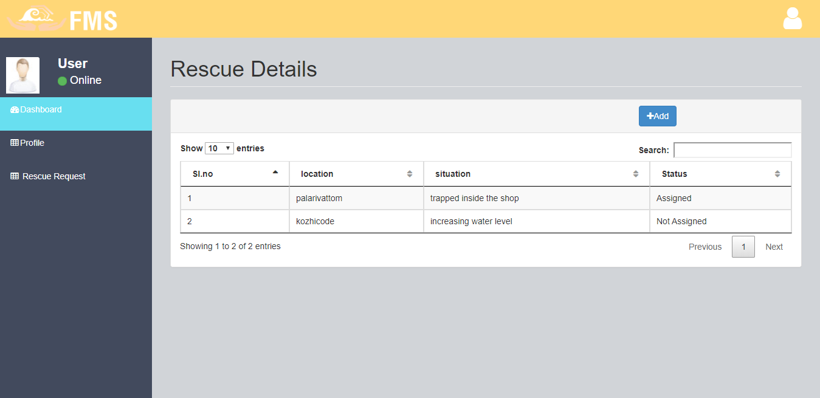

**6. ASSIGN REQUEST TO QRT**

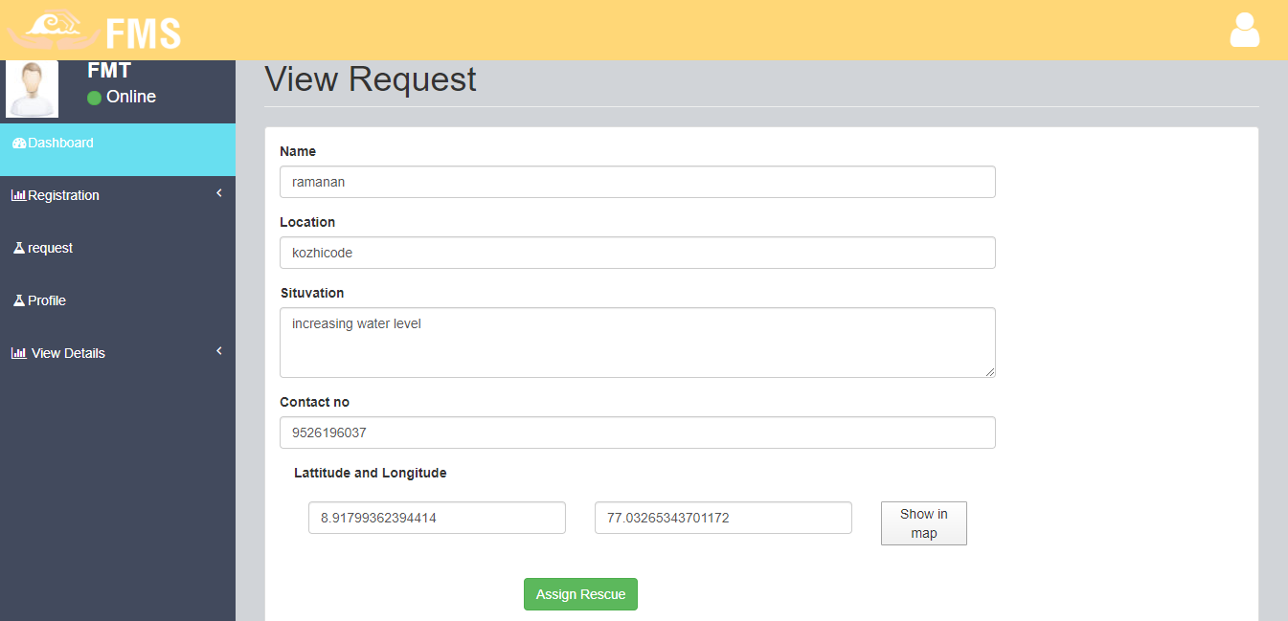

**7. CAMP REQUEST**

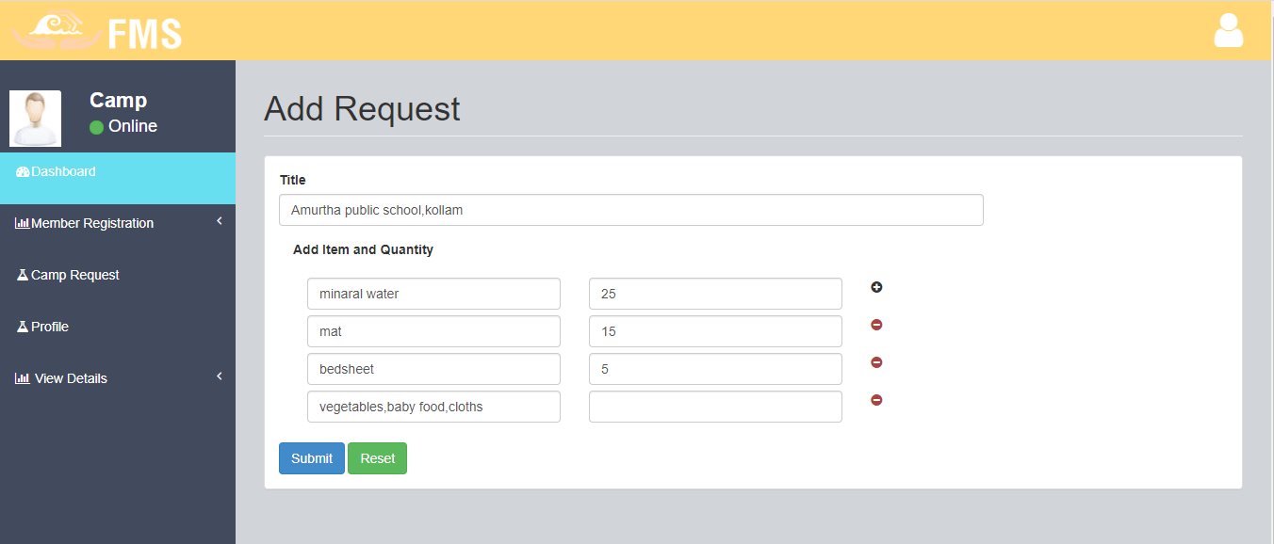

**8. REGISTER QUICK RESPONSE TEAM**

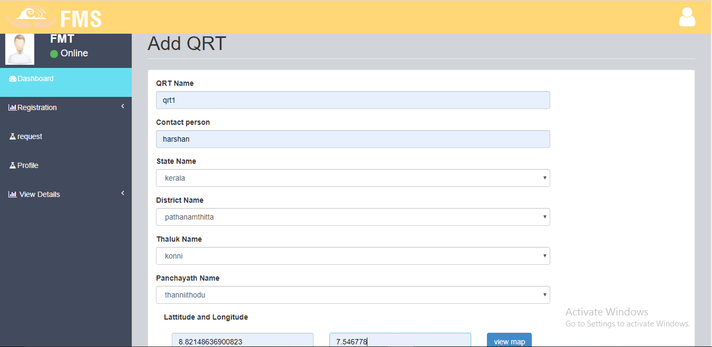

**REFERENCES**

**BOOKS:**

1. ANDREW. S. TANENBAUM, System Analysis, Prentice Hall India

Publications, Year 2000

2. Database Design Concepts 5th Edition, Abraham Silberschatz. Year 2007

3. Rajib Mall, Fundamentals of Software Engineering, Third Edition, PHI Learning

Pvt Ltd., Year 2009

4. Ali Bahrami, Object oriented systems development, TATA McGraw-Hill. Year

2008

**WEBSITES:**

* <http://www.mysql.com>
* <http://www.phpeasystep.com>
* http://w3schools.com